3D MODEL OF GSS SCHOOL
Portable weather station and its inner workings with an overlap to self-sourcing of energy from a mobile power plant

MIKULOV Gymnasium and Secondary Vocational School, p.o.
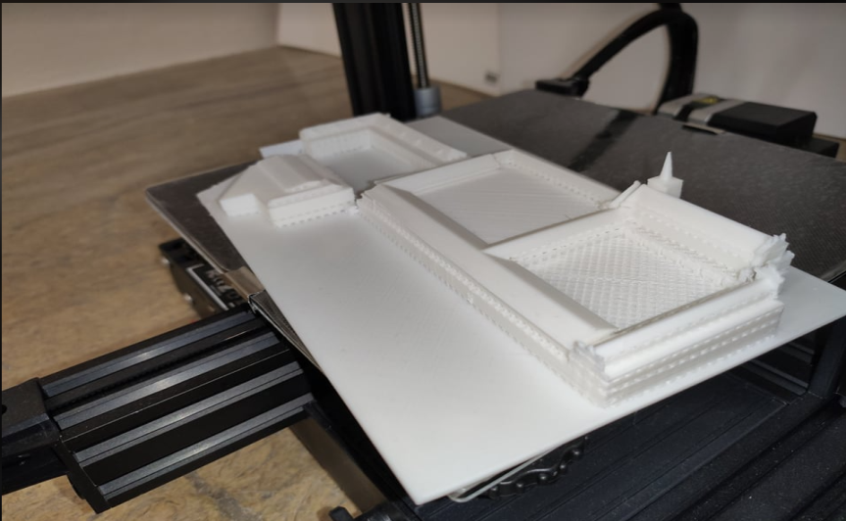
Komenského 7, Mikulov

Contents:
Annotation and objectives of the project 3
Project objectives 3
Annotation of the project 4
Equipment 5
Schedule 6
Theoretical basis for implementation 6
Work progress – project implementation 7
Project output 23
Evaluation 30

Annotation and objectives of the project

Project objectives
Pupils will be divided into working teams of Scientists and Promoters, when the scientists will process the 3D model of the school and the promoters will promote the scientific work.
Pupils will design the structure of a 3D model of the school in the SketchUp program. They will then edit it in virtual reality.
Pupils create a 3D model and print it on a 3D printer.
Pupils will learn about the functioning of virtual reality, 3D modelling in SketchUp and 3D printing.
Pupils will become familiar with the use and creation of models of real world objects in virtual reality. Using a 360° camera, they will record the premises of the school and create a virtual tour in virtual reality. The work of the "propagators" will be used to present the school on the school's website, YouTube, and also as part of the project's output.

Annotation of the project
The aim of the project is mainly to familiarise pupils with modern technologies, to arouse in them an interest in science and technology in accordance with the concept of education 4.0. Pupils learn to use technology, decide on the appropriateness of their use. The student group also acts as a dynamic group, where individuals agree on a unified purpose for the whole group, divide roles and discuss individual steps. Teachers only act as mentors and assistants, they do not bring their own ideas into the project. The system of project activities is in four pillars focused on planning and modelling work, building a functional model and collecting data, creating a digital model and monitoring the progress of work. The purpose is to show pupils the importance of good promotion of their own work and the repeatability of this work. Pupils learn to record the individual steps of the work not only in text, but also with a video recording, then process and appropriately comment on it. This phase of the work should result in a work methodology and a document suitable for presentation.

Equipment

Product | pc | Price | Link
3D printer Creality CR-10 | 1 | 12 361,00 CZK | https://www.alza.cz/creality-cr-100?dq=5853390
PLA material different |  | 3 591,00 CZK | https://www.alza.cz/filamenty-pro-3d-tiskarny/18854774.htm
Virt. Oculus Quest reality | 1 | 14 990,00 CZK | https://www.alza.cz/gaming/oculus-quest-64gb-d5616794.htm
360st. GoPro camera | 1 | 10 990,43 CZK | https://www.datart.cz/outdoorova-kamera-gopro-fusion-chdhz-103.html?desktop=true
Notebook Lenovo Legion | 1 | 29 490,00 CZK | https://www.smarty.cz/Lenovo-Legion-5-Pro-RTX-3060-82JQ002KCK-sedy-p71966?utm_source=google&utm_medium=cpc&utm_campaign=PLA_N&utm_adgroup=M2N3&gclid=Cj0KCQiAk4aOBhCTARIsAFWFP9Hdly336U3tQ_2s1Mjnyv7prgdQNLkAOfpI-zSs3pEOaKqGqQCHnjIaAtCXEALw_wcB
Windows 10 PRO | 1 | 4 040,00 CZK | https://www.alza.cz/microsoft-windows-10-pro-cz-64-bit-oem-d2817680.htm
Pam. 128 GB MicroSD card | 2 | 1 482,00 CZK | https://www.alza.cz/sandisk-microsdxc-128gb-extreme-a2-uhs-i-v30-u3-sd-adapter-d5489137.htm
AA rechargeable battery | 3 | 1 137,00 CZK | https://www.alza.cz/gp-eco-e411-4-aa-recyko-2000-d5867005.htm
SketchUp EDU 1 year lic. | 1 | 1 588,00 CZK | https://www.sw.cz/vyvojove-nastroje/sprava-projektu/sketchup-pro-2020-cz---edu-online-licence-pro-studentaucitele-na-1-rok/
Mouse Logitech MX Master 2s | 1 | 2 377,00 CZK | https://www.alza.cz/logitech-mx-master-2s-2020-d6233873.htm?o=2
Ender 3 3D printer | 1 | 6 600,00 CZK | https://www.alza.cz/creality-ender-3-v2-d5875570.htm?kampan=adw1_tiskarny-a-skenery_pla_all_obecna-css_tiskarny-3d_c_1003729___ENDER01V2_414224454410_~91737504643~&gclid=Cj0KCQiAk4aOBhCTARIsAFWFP9EmWReGSvDinDj72FMS-Smq56UBBZVqMLSMCl-bolxAGSb1NKF_TrIaArLyEALw_wcB
VR SKetch Academic | 1 | 0 CZK CZK | https://vrsketch.eu/
Total price |  | 88 646,43 CZK

Schedule

- phase – filming and photographing the school
- phase – building a toy car that will carry the camera, from Lego Mindstorm in combination with the Gigo kit
- phase – shooting the interior and exterior with steady walking
- phase – video post processing - placement on youtube
- phase – students learn to work with the SketchUp program
- phase – modelling of the school building in the SketchUp program
- phase – Transferring the 3D model to virtual reality
- phase – printing the school model on a 3D printer

Theoretical basis for implementation
Students will learn how to work with SketchUp at a beginner level. They also control the formats for saving the created model, its transfer to virtual reality and the slicer for 3D printing. They should have an overview of how a 3D printer and virtual reality work. The most important thing is to learn to work together. Pupils organise the project themselves. They divide the work themselves and monitor what needs to be done.

Work progress – project implementation

1. Phase – filming and photographing the school
To create a 3D model, we first need to photograph the entire school, record a 360° video. We need this template in order to have an idea of ​​how the individual walls, corridors, roofs, classrooms and floors look in 3D modelling in the SketchUp program. Pupils were looking for ways to film the corridors of the school. They used a GoPro Fusion camera for this, which needs two SD cards to shoot, one for the 180° front camera and one for the rear camera.
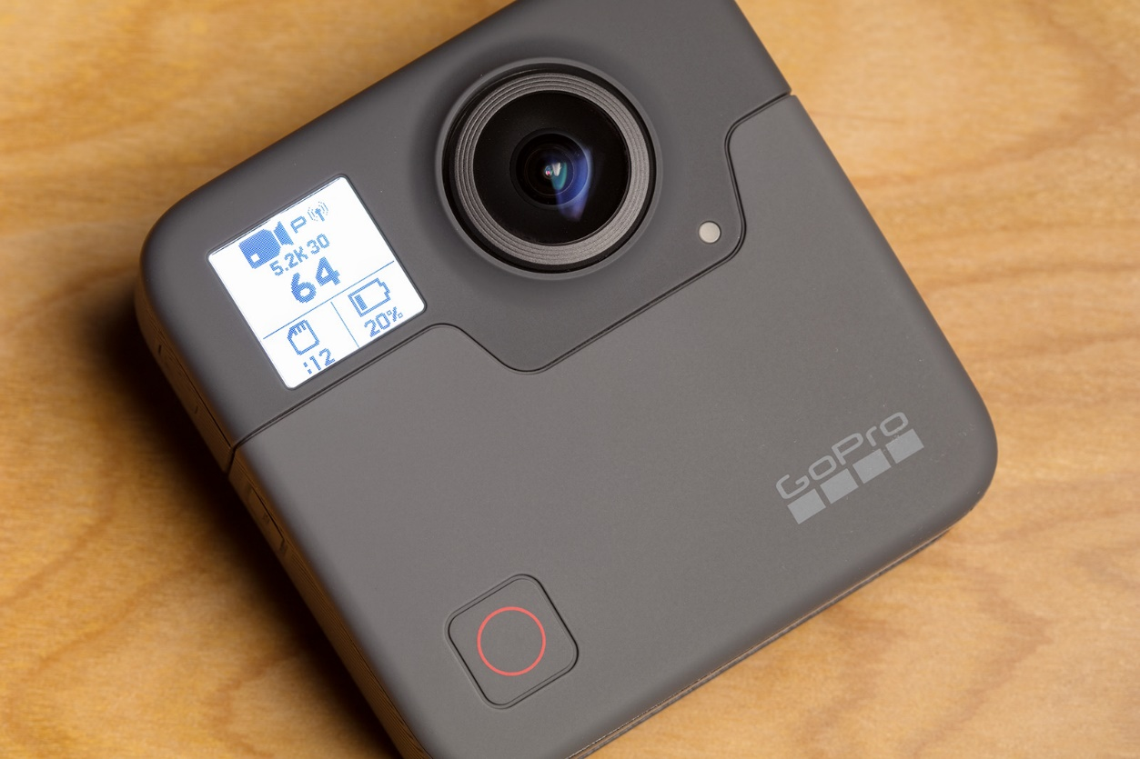

The biggest obstacle is the instability of the image, its fluctuations and variable speed of movement. One student thinks of bringing a scooter to school. We shoot the video by placing the camera between the handlebars. Then we bounce off the scooter and film the whole school like that. Unfortunately, the footage from the camera was not of good quality either. Even if we weren't bouncing on a scooter, but just standing and holding the camera and someone else was pushing it down the hall.
We can think of using a longboard as another way. The initial idea is to put the camera on the board itself and then start riding on it. But that's where we run into a problem – it’s impossible to record a stable video if we're bouncing around on a skateboard. We don't give up and keep coming up with more ideas on how to make a video.
- Phase – building a toy car that will carry the camera, from Lego Mindstorm in combination with the Gigo kit
First, we assembled a lower toy car that was supposed to guarantee stability for the camera. Unfortunately, if the camera was close to the ground, the resulting image was not very nice, as most of the image was the ground. That's why we built a new, taller car. Here again we encountered another problem, namely that the camera was unstable and the image was very shaky.

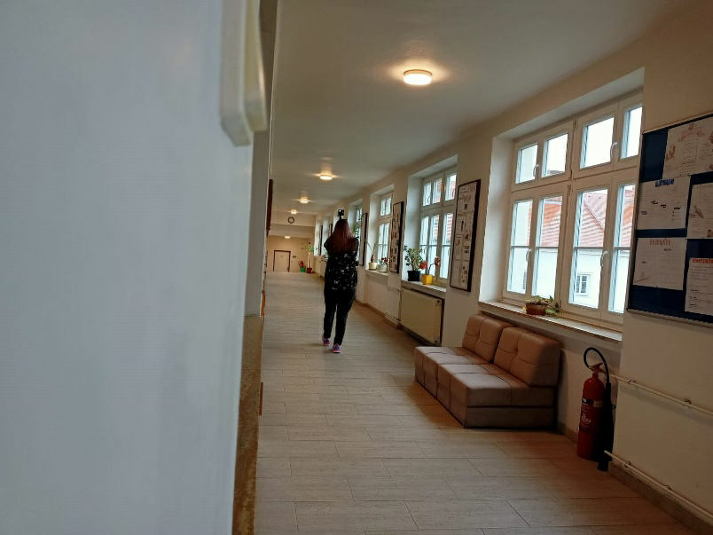

- phase – filming the interior and exterior with steady walking
The best suggestion is to take the camera in your hand and shoot the corridors like this. At first we thought it wouldn't be of good quality, but in the end the teacher told us that it was the best footage of all. So we went through the whole school and created a 360° video of the whole school.
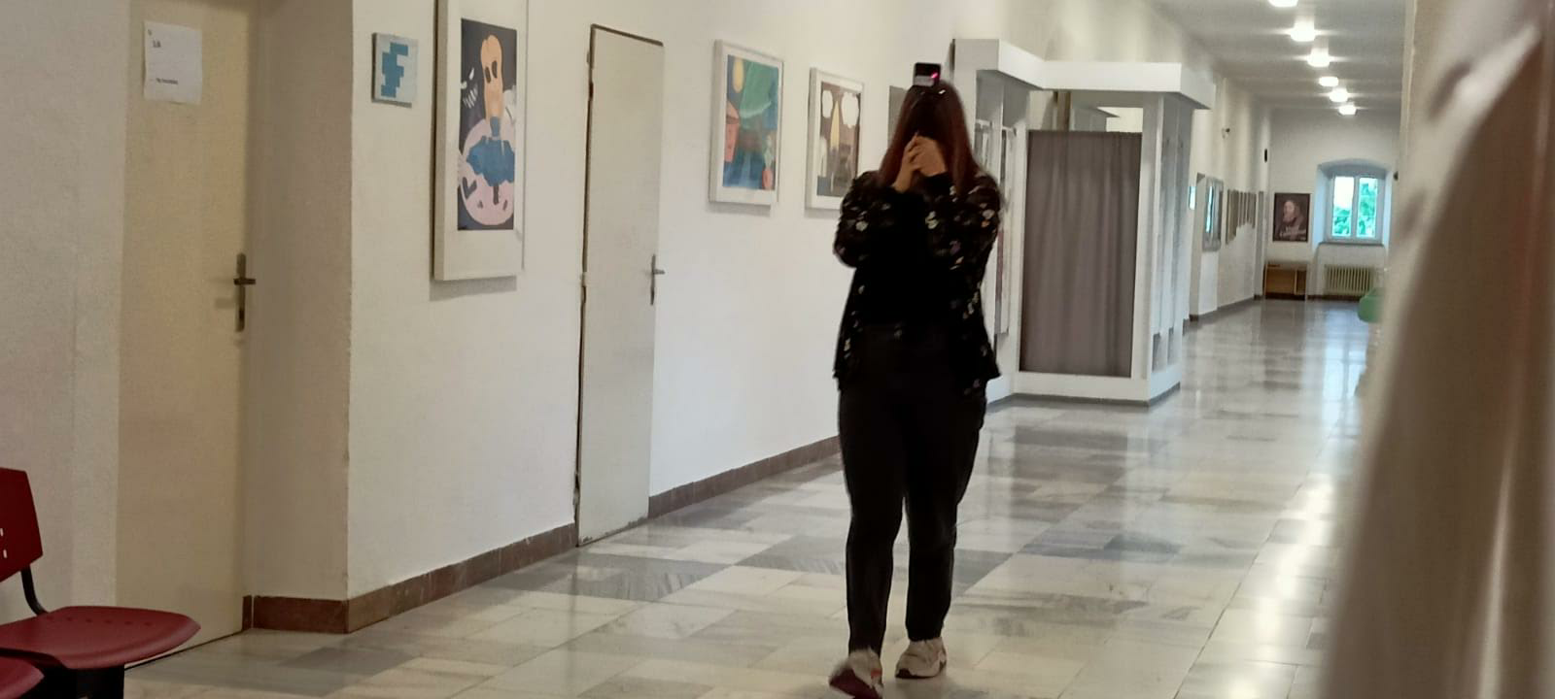

- Phase – video postprocessing – placement on youtube
We then transferred the video from the GoPro camera to Google Drive using a mobile phone application. The Go Pro camera mobile app called GoPro Quick: Video Editor & Slideshow Maker is available for both Android and iOS mobile devices. The problem with the application is the need to connect to the camera using the WiFi network that the GoPro camera creates. Subsequently, the necessity to connect the mobile phone to this WiFi network. The GoPro Quick mobile application then pairs the camera, we select the videos we want to transfer, we choose download. Another problem is that even after downloading videos from the camera to the app, these videos cannot be found on the phone and transferred outside. Even after displaying them in the downloaded files, it is necessary to send them to an external application for sharing. This is where Google Drive worked best for us.
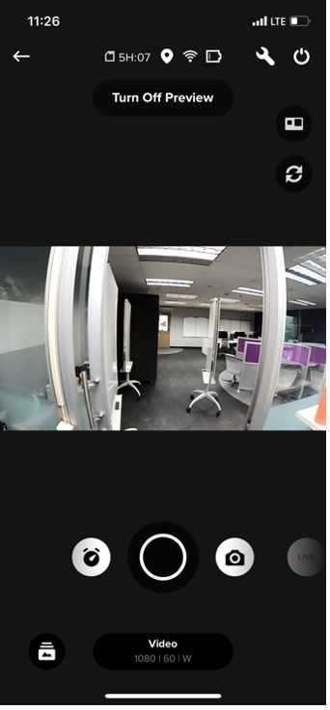
From Google Drive, we then placed the videos on the school's YouTube channel using a notebook, edited and added some melodies that Youtube offers for free. There are a limited number of free software tools available for editing a 360degree video, so we recommend using the YouTube editor itself, which is free and the outputs can be published immediately.
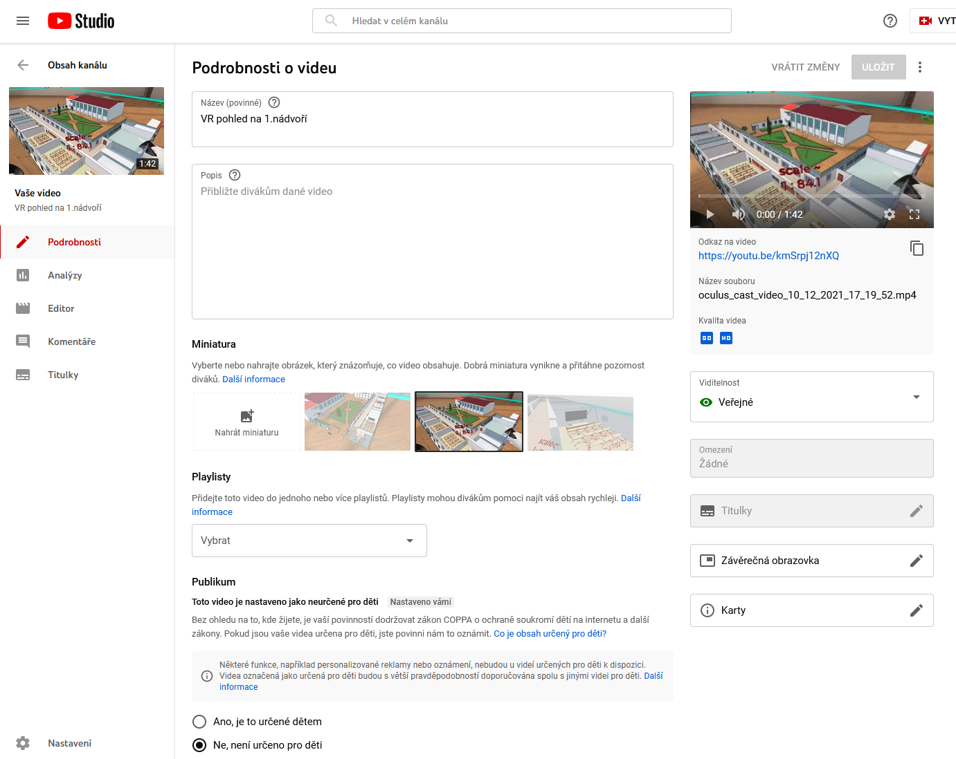

- Phase – students learn to work with the SketchUp program
The first step is to purchase an annual licence of the SketchUp program, download it, install it and activate the licence. Everyone in the class will try out how to work with the SketchUp program. Since we only had the purchased SketchUp EDU licence for 1 computer, for learning the basics we can recommend the free version of SketchUp called SketchUp for Schools, which is available for free in G Suite from Google as an optional addon accessible immediately to all students after logging into the school email.
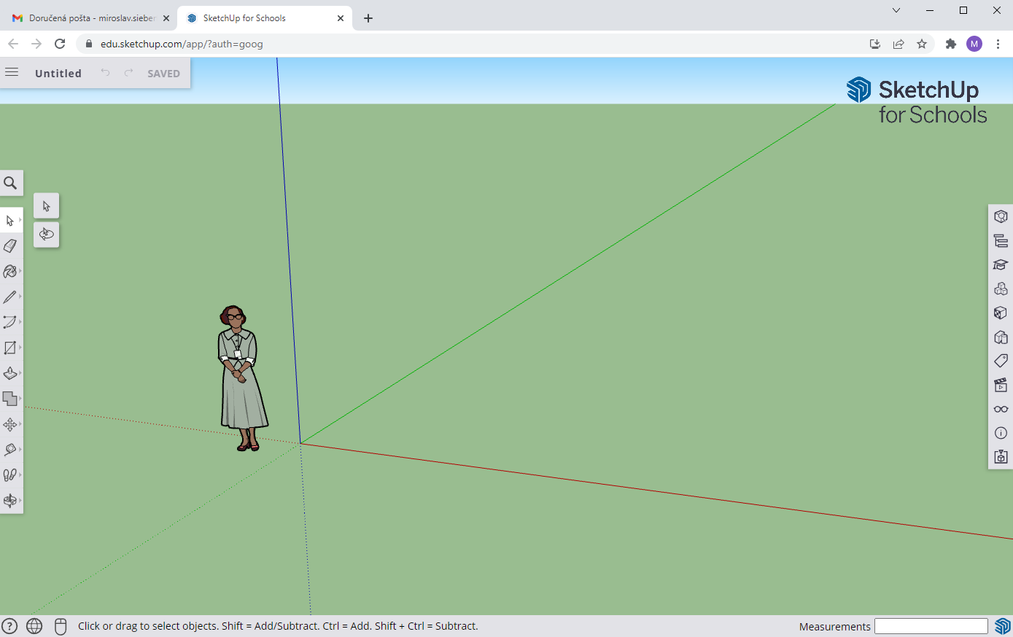
Although this version of SketchUp is limited, it does not support all the export formats we need, it is used directly in the web browser, but it is more than sufficient for learning the basics of 3D modelling. Created models can be saved directly to Google Drive. In the mentioned tool, we learned to model basic shapes, use individual functions of the program and their use for the later design of the interior model of the school.
SketchUp is similar to paper modelling in many ways. All models consist only of edges and faces. Both components are infinitely thin. Surfaces can be created using edges. The basic premise is to create a closed shape in one plane, SketchUp then creates the surface itself.
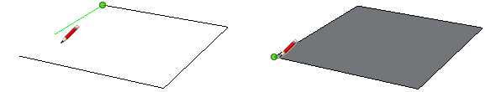
If you delete an edge, the surface that it is connected to will also disappear. When you delete a surface, the surrounding edges are preserved. Surfaces can be easily added to the model by recreating the deleted edges. If all edges exist, just redraw one of the finished edges.
Here we come to another interesting feature – if you draw several line segments over each other, SketchUp will not be able to distinguish between them. However, if you create segments of different lengths, SketchUp remembers the endpoints and splits the segment. This is most noticeable when drawing a shape – the dividing point is rewritten into the final appearance and creates an edge on an otherwise flat surface.

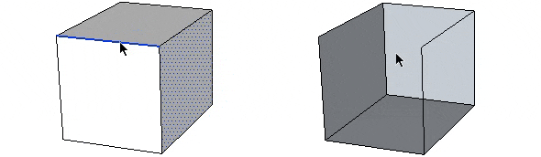
Each surface can be imagined as a sheet of paper that can be colored on both sides with different colours. SketchUp goes beyond reality and allows you to colour one side as transparent as glass and the other as a solid material. However, the practical use in modelling is not essential.

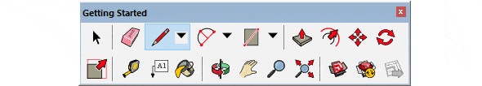

Camera – Zooming, view shift, orbit (camera rotation).
Practically basic actions that can be done with the mouse without any problems. However, the panel also offers some more advanced functions. On the one hand, there are more advanced options for zooming through the selection rectangle, a back button for the camera only, or the ability to walk through the model from the pedestrian horizon (formerly the Walktrough panel). An excellent function is the Zoom Extends button, which zooms the boundaries of the entire model. This is invaluable when you get "lost" in modelling or need to see all the connections.
Construction – Measuring distances, angles, dimensioning, creating labels and 3D text. Panel construction is part of the Large Tool Set and does not need to be turned on.
Solid Tools – Clipping models together and creating intersections. Unfortunately, a very powerful tool for creating more complex models is only available in the SketchUp Pro version. Only the relatively useless Outer Shell tool is available in the free version.
Drawing – Drawing straight lines, basic shapes, circles, curves and polygons. A less common feature is freehand drawing. Also part of the Large Tool Set.
Styles – Ability to temporarily turn on or off textures, x-rays or line views.
Warehouse - Share and download models, access 3D Warehouse.
Layers – A simple toolbar for working with layers. Layers can be added via the menu: Windows – Default Tray – Layers. Layers allow you to temporarily hide a group of elements to which you assign a common parameter – a layer.
Measurements – Accurate measurements can be entered during modelling. The panel is a simple practical box where you will automatically see the entered dimension.
Principal – Creating components, paint bucket and eraser. These basic tools are already part of the Large Tool Set.
Sections – Basic tools for creating sections.
Shadows – Turning direct lighting on and off, including shadows, setting the month and time of day.
Edit – This is where the real magic happens. Extruding faces, scrolling, rotating, scaling, moving along a curve. Part of the Large Tool Set.
Standard – Basic file operations – saving, opening. Copy, paste or delete. Nothing that sloppy keyboard shortcuts can't handle.
Views – Switching between individual views. Axonometry can then be turned off in the menu: Camera – Parallel Projection.

To work well with SketchUp, you will definitely need a mouse with a wheel. The wheel is important for zooming in and out of the model. In this case, the mouse cursor serves as the point to which we zoom. By pressing the wheel, we activate the Orbit mode, i.e. the possibility of spatial rotation. The same effect can be achieved by pressing the O key and holding the left mouse button. Dragging the mouse indicates the direction of the camera movement. Another great feature is the view shift, which can be activated if we hold the Shift key in Orbit mode. In this mode, we do not rotate the camera, but only move it to the sides.

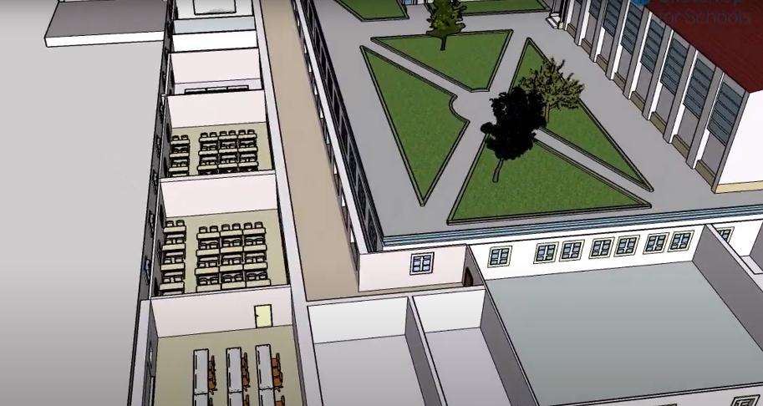
- Phase – modelling of the school building in the SketchUp program
Modelling the school in SketchUp began with a thorough study of the already created model of the exterior of our school building. First, we made a rough design of the individual rooms according to the ground plans of the school. After creating individual walls, we marked the places for windows and doors and found out, for example, the number of benches. The next step was to find suitable models of desks and other equipment for classrooms. In the warehouse, where people can upload their created models, we found exactly the type of benches we needed. Then all you had to do was copy them and place them in the classrooms. Another important step was the creation of staircases, which we have many in the school. We created the staircase from a solid block by "carving" it. Then it was just a matter of adjusting it to fit the pre-created cutout in our model.

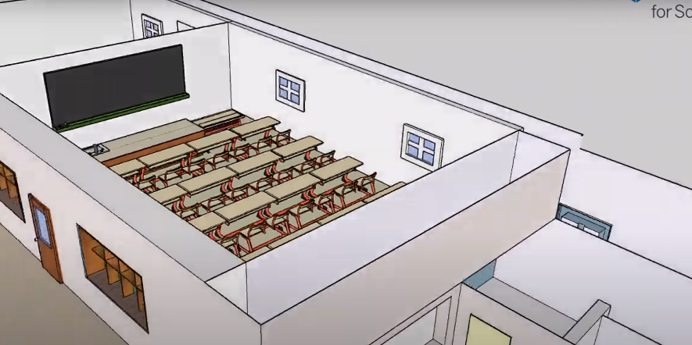

- Phase – Transferring the 3D model to virtual reality
After completing the 3D model in the SketchUp program, we transferred it to the virtual reality Oculus Quest 2. For the transfer itself, you need to install the VR Sketch plugin https://vrsketch.eu/ and an internet connection to SketchUp. It is available under an academic licence free of charge. After it starts, the ID will be displayed. Virtual reality requires downloading and installing VR Sketch on Oculus, which is available in the Oculus app store https://www.oculus.com/experiences/quest/3557027837758788/. After starting this application, we enter the ID generated for us by the VR Sketch plugin in SketchUp. Subsequently, our 3D model will start to drag and drop, see picture. The model itself will appear inside a blue square.

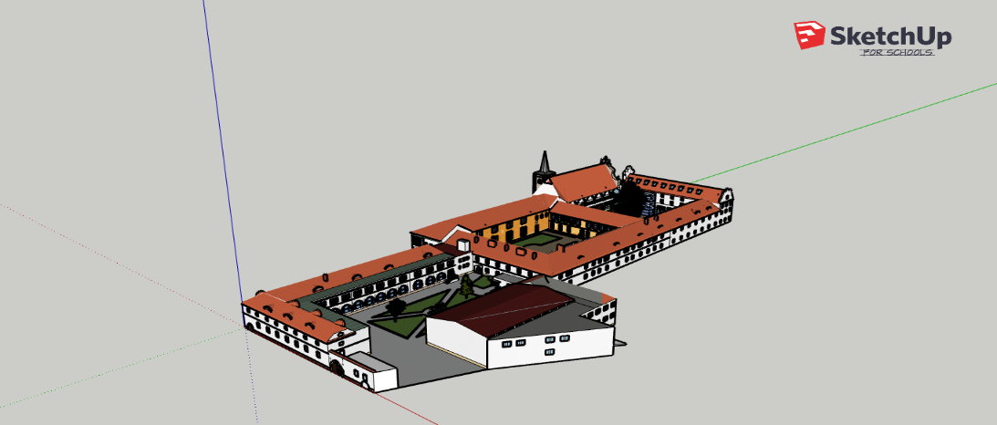

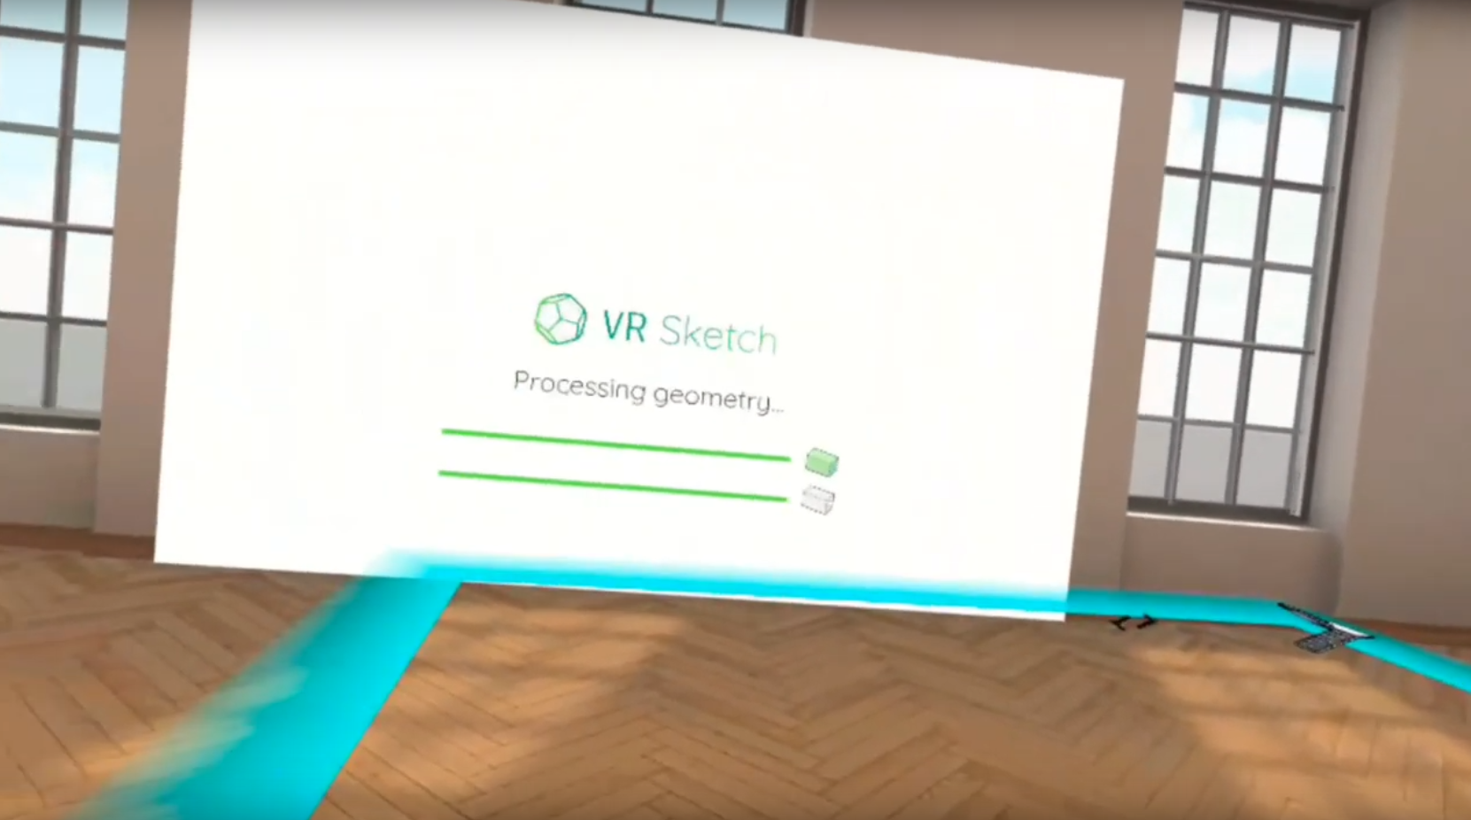

You can then work with the model itself in virtual reality. It can be rotated, zoomed and even edited. Using the buttons on the controllers, we select the desired tool and we can erase, change, texture of the model walls, look for errors in the model and fix them right away. As our 3D model of the school is very large, we divided it into 3 models according to the courtyard.
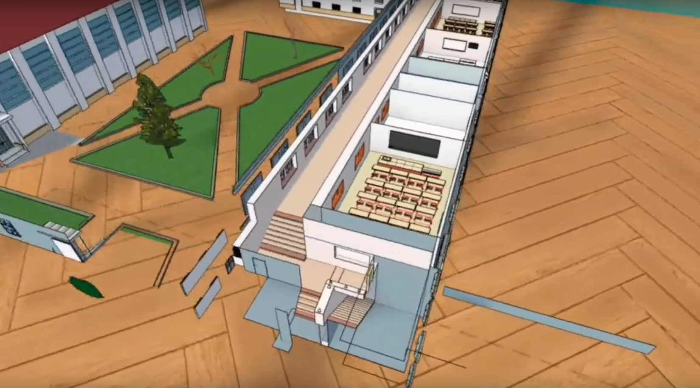
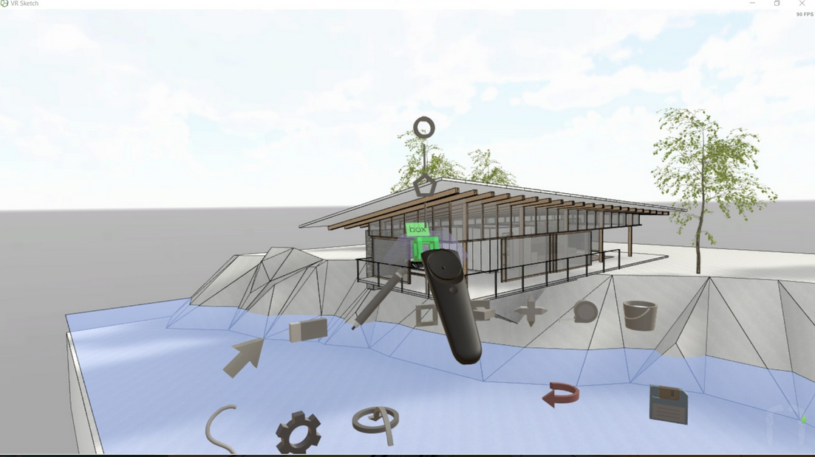

- Phase – printing the school model on a 3D printer
Printing was very tedious and demanding. We had to learn how to transfer the model created in SketchUp to the slicer and then directly to the printer, which printed the weather station we designed. For printing we downloaded, installed Creality Slicer v.4.8.2,

available here: https://www.creality.com/download. For the slicer function, we need to export the model in. skp format from SketchUp. We then import it into the Creality Slicer, adjust the size of the model itself so that it fits on the printer's surface.
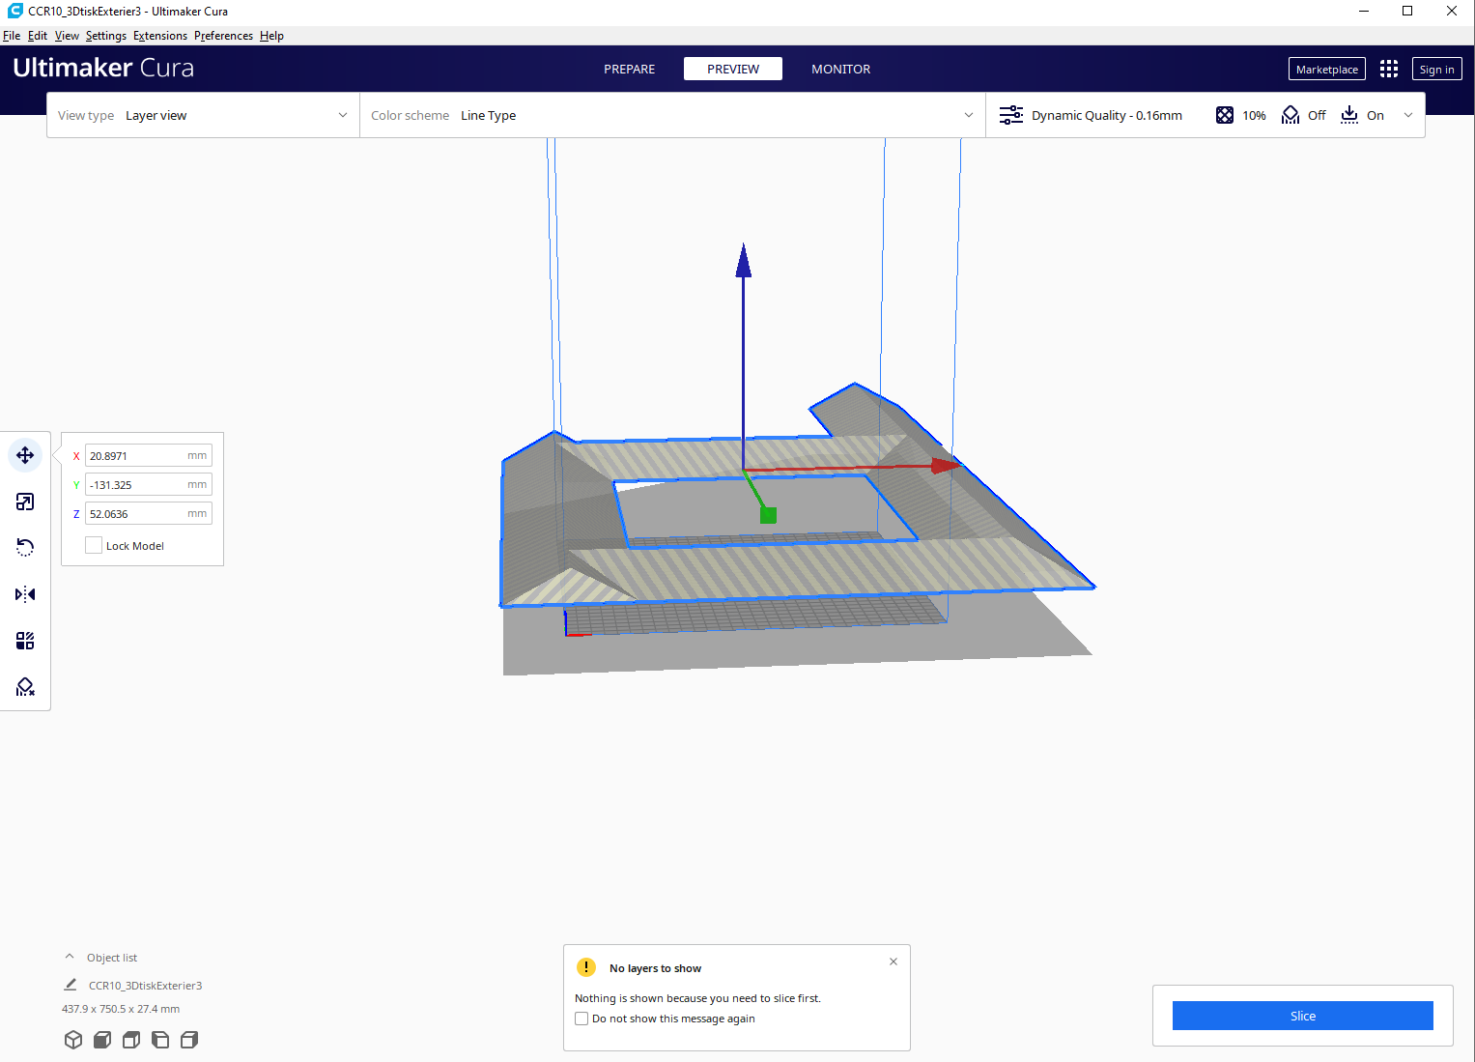

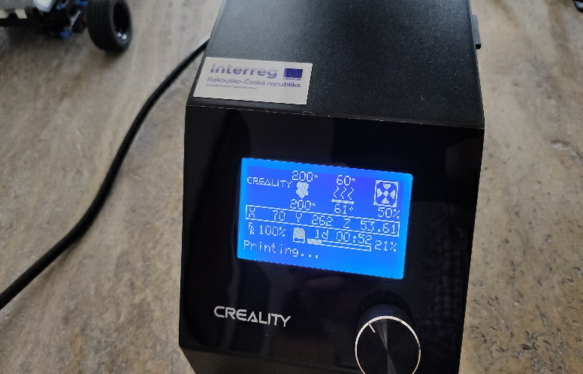
We also had to try different slicer settings, as even a small change affected the final printout. We needed to transfer the file for the 3D printer to the printer using an SD card. After inserting it into the printer, we select Print from TF with the rotary selector and find our file name, as we named it in the Creality Slicer Ultimaker Cura program environment. Slicer will automatically remove excess stuff, add support for elements that wouldn't hold in the air.

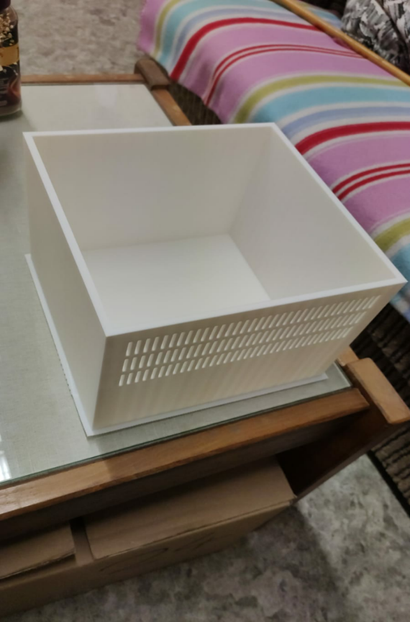

During the printing time, we have to check the printer regularly to make sure it doesn't run out of filament, or it may detach from the mat at the beginning, or there may be a hidden error in the model that will cause the model to collapse.

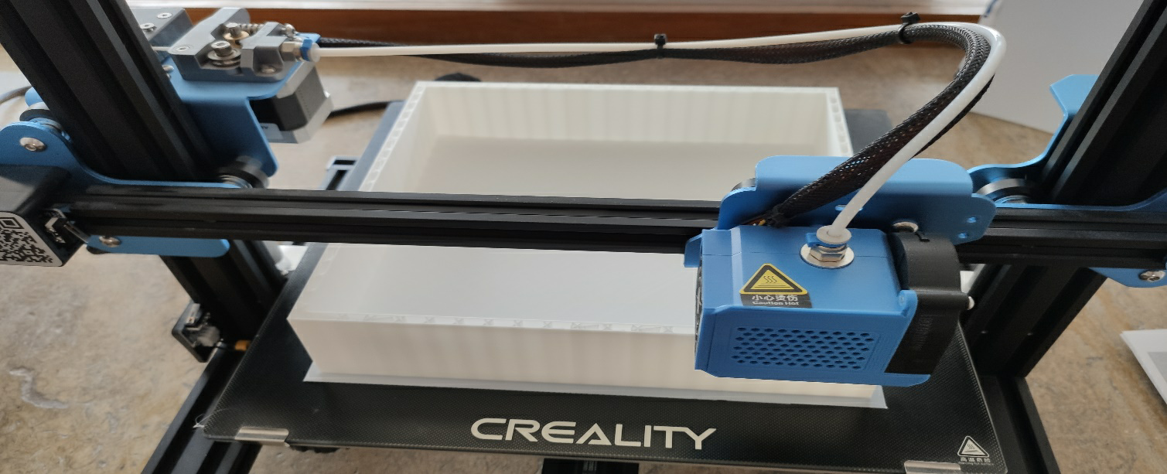

As the last step, we printed the model we created on a 3D printer. Each piece took about 8 hours to print. We printed the basics first, as we couldn't print the whole model at once due to time constraints. So after printing the foundations, we printed the roof as well and joined the individual parts with a melt gun
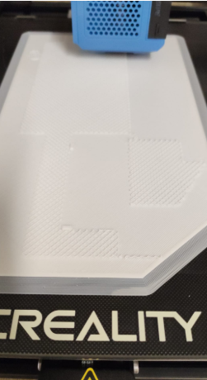
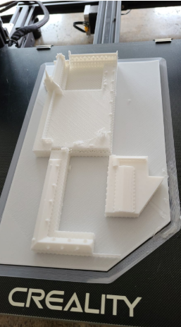
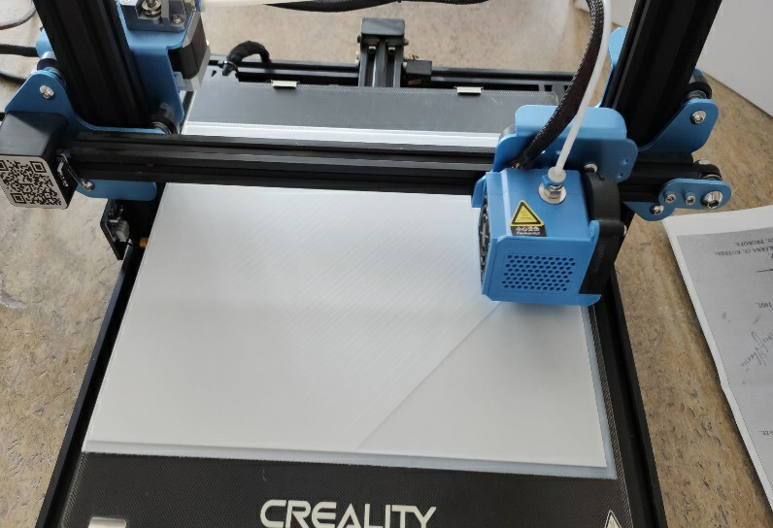
We then transferred the created 3D model of the school to the application in virtual reality with the help of the VR Sketch add-on for SketchUp, where we filmed the passage through the 3D model and then uploaded it to the school's YouTube channel.

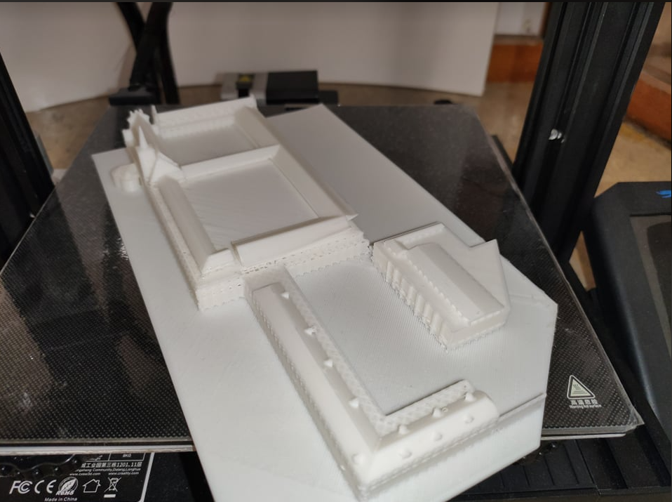

Project output

- 360° tour of the interior and exterior of the school:
shot on a 360° camera also used to promote the school here:

Part 1 of the 360° GSS video:
https://www.youtube.com/watch?v=5DFfzB7fn3Q

Part 2 of the 360° GSS video:
https://www.youtube.com/watch?v=cSNhImn1sL4

Part 3 of the 360° GSS video:
https://www.youtube.com/watch?v=AD8XV3CoTLw

Part 4 of the 360° GSS video:
https://www.youtube.com/watch?v=pqLG1qnaKRI

360° video of the GSS courtyard:

https://www.youtube.com/watch?v=1uhErsfwX88

With a 360° video, you can use the mouse cursor to move in all directions. In the case of playing in virtual reality, it is enough to turn the head and the observer feels as if he is on the spot.

- Interior 3D model of the school created in SketchUp
- tour exported to video directly by SketchUp, here:
https://www.youtube.com/watch?v=qjqNeJBgQhM
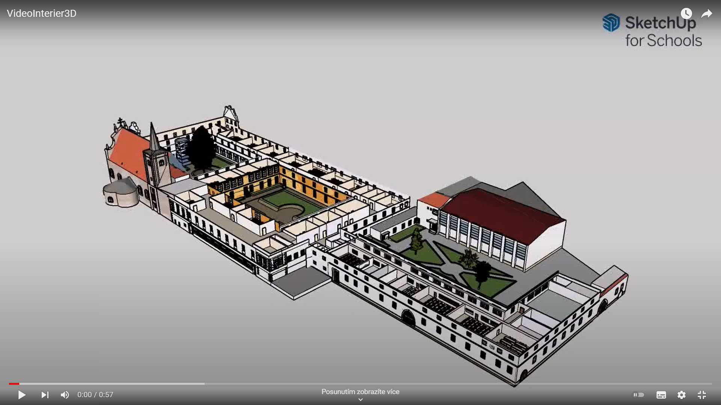

-tour of the 3D model of the school in virtual reality here:
https://www.youtube.com/watch?v=kmSrpj12nXQ
https://www.youtube.com/watch?v=7n-8ga_cNzU
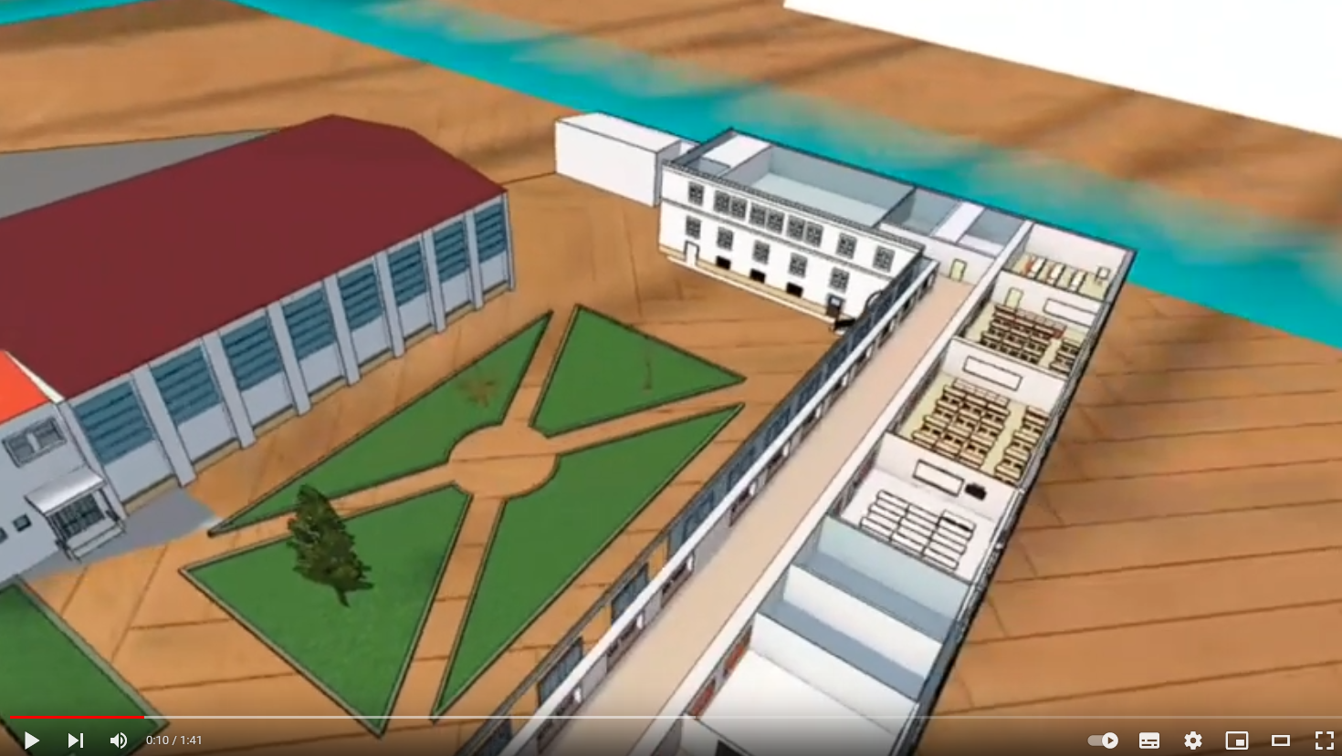

- Using a website plugin, we placed the 3D school model on the school website, where everyone can view, zoom in, rotate and play with it. Also to better orient oneself in the premises of our school. Available here:
https://gssmikulov.cz/sluzby/digime/
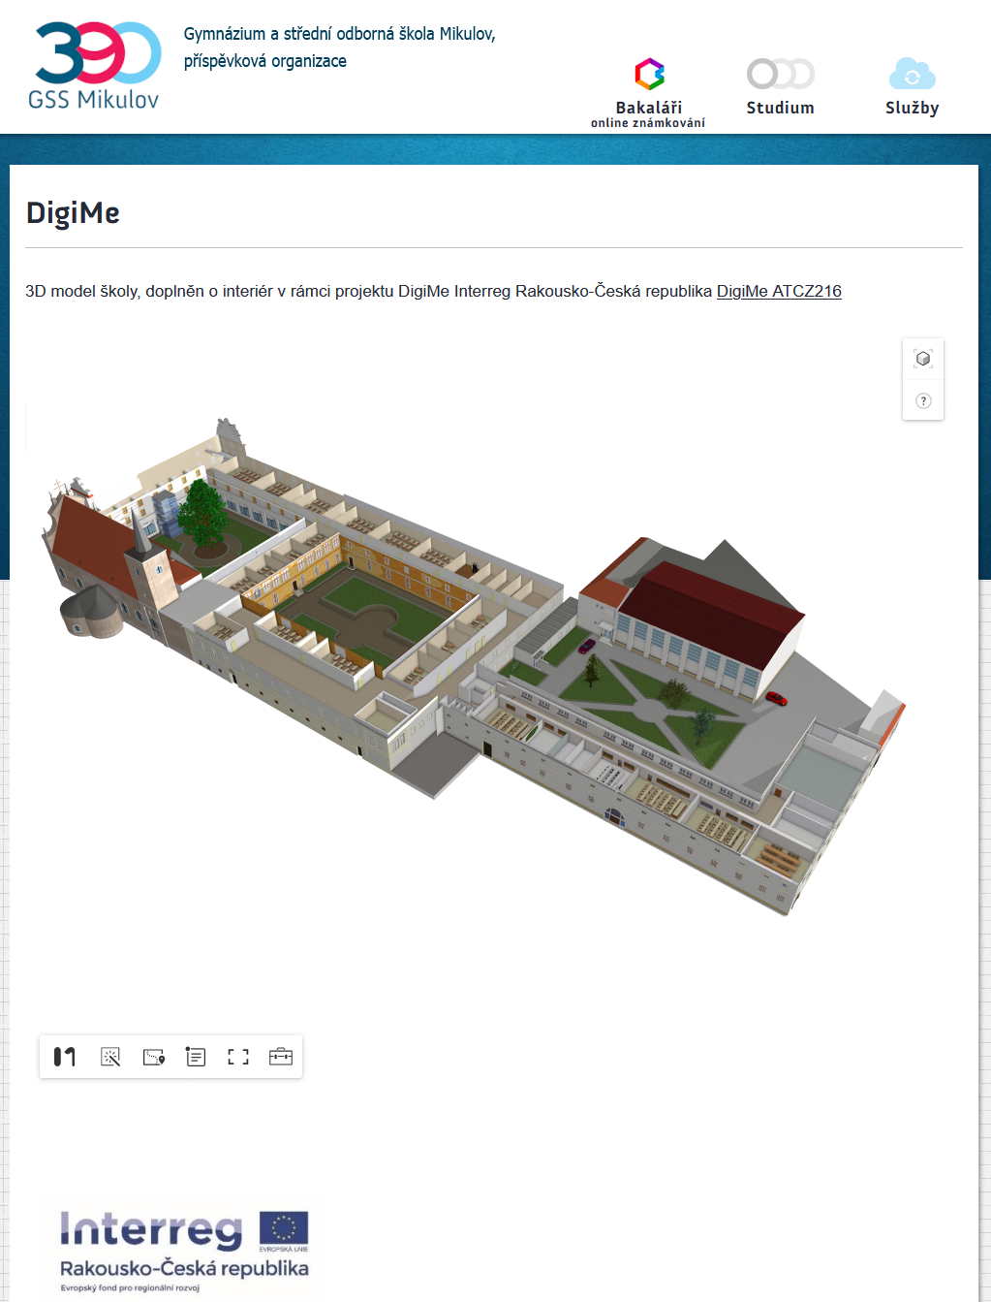
Interior added to the 3D model (DigiMe project)
- Printed 3D model of our school on a 3D printer.
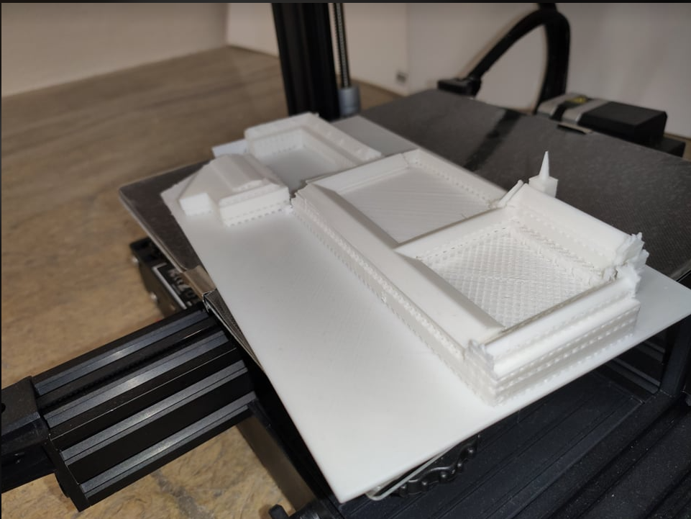

Evaluation

It is important to create your 360 video at a slow speed so that it can be scrolled through when modelling. Photos of the places are not needed. For creating and working in SketchUp itself, it is advisable to take training courses for beginners, some of which are also available online. The work itself from Creality Slicer is intuitive and undemanding. We have to set aside a longer period of time for the 3D printing itself. The project fulfilled its purpose of familiarising pupils with the latest digital technologies and helped to arouse pupils' interest in working with this technology in an interesting and playful way. The outputs of the project can be used both to promote our school and to introduce 3D modelling to future students, they will serve for better orientation around the building of our school for visitors to our website. The experience gained not only by the students who worked on the project, but also by the teachers and other generations is a significant benefit.

